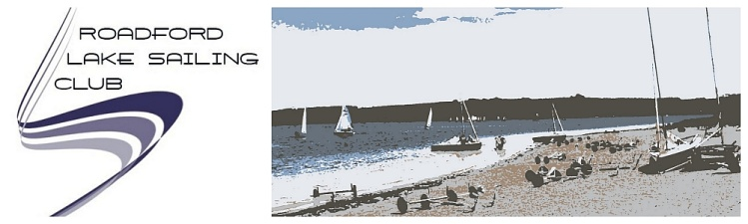
The Committee of Roadford Lake Sailing Club and the staff at the Watersports Centre look forward to welcoming you to the second Roadford Rocket on Sunday February 28th which this year is kindly sponsored by Exe Sails.
The second stage of the SW challenge 2016 will be the Exe Sails Roadford Rocket on Sunday Feb. 28th , start 1200. The event this year will be a 3hr pursuit race in the same format as the Starcross Steamer and Wimbleball Beastie, and will again be a charity fundraising event, raising money for the Calvert Trust for disabled sailing in N Devon. Please see their website for further details of their activities:
http://www.calvert-trust.org.uk
The event is open to monohull dinghies with cadet PY or faster & keelboats LOA 20’ or under.
Entries this year will be through the club website, but payment will be on the day. Please download the entry form and save to your computer , fill in and send by email or post to the organiser (email below), then print off & sign & bring to the event. Please note that this is an entry form & sailing permit for Roadford Lake , so there will be no additional paperwork to complete on arrival! The club understands that competitors will not make a decision to travel until the forecast is clear, but if you think you will come, please enter and send an email if you cancel later. This will enable the start list to be populated.
Catering will be by Farmhouse Fare Mobile Caterers – Okehampton, which we hope will be much better than last year, catering will be available from 9.30am.
Event Documents: Entry Form; Sailing Instructions; Sailjiuce PY list
RLSC Mark Map
If you have any queries, please contact the organiser , Richard Willows at richardwillows@doctors.org.uk

