INTERNATIONAL CONTENDER AND OSPREY DINGHY OPEN MEETING
Saturday 30th June and Sunday 1st July 2018
Organising Authority - Poole Yacht Club
Poole Harbour

NOTICE OF RACE

1. RULES

1.1 The regatta will be governed by the rules as defined in The Racing Rules of sailing 2017 – 2020.

1.2 Competitors shall wear personal flotation devices at all times whilst afloat, except briefly while changing or adjusting clothing or personal equipment. Wet suits and dry suits are not personal flotation devices. This changes RRS 40 and the preamble to part 4.
1.3 The Exoneration Penalty, the advisory hearing and the RYA Arbitration or the RYA Rules Dispute Procedures will be available. In the event of any conflict, the Sailing Instructions shall apply.

2. ADVERTISING

2.1 Boats may be required to display advertising chosen and supplied by the organising authority.

3. ELIGIBILITY AND ENTRY

3.1 The regatta is open to all boats of the Contender and Osprey dinghy classes.

3.2. Eligible boats may enter by completing the attached entry form and returning it with the required fee to The Poole Yacht Club or enter at registration.

3.3 Competitors who are under 18 before and including the last date of the event must have a declaration form completed by their parent or guardian before they will be allowed to compete. The parental declaration form is part of the entry form.

4. FEES

An entry fee of £32 is required for Osprey boats and £27 for Contenders. There is onsite overnight parking at the club for camper vans for which a charge of £16 per night is levied. Please contact the club office to book an overnight camper-van parking slot.

5. SCHEDULE

5.1 Registration will be in the ‘Sailing Academy’ between 0900 – 1030 on Saturday 30th June and 0900 - 0930 on Sunday 1st July.

5.2 Competitor Briefing: There will be a briefing for competitors at 11:00 on Saturday 30th June.

5.3 Dates, Times and Number of Races
5.3.1 The event will be an up to six race series held over two days.

Date | Time of warning signal | Notes
Saturday 30th June 2018 | Race 1 Not before 11:55 | Race 2 and then Race 3 to follow Race 1 back to back
Sunday 1st July 2018 | First race of the day not before 10:25. No warning signal will be made after 14:55 | Subsequent Races follow back to back

6. CONTENDER AND OSPREY CLASS ASSOCIATION MEMBERSHIP AND MEASUREMENT
6.1 Competitors are to be members of their Class Association and have a valid class measurement certificate.
6.2 Contenders are strongly recommended to carry a suitable tow rope for Poole harbour racing. Ospreys carry a tow rope in accordance with class rules.

7. SAILING INSTRUCTIONS

7.1 Sailing Instructions will be available at registration and may be available on the Association web sites beforehand.

8. VENUE

8.1 The venue will be Poole Yacht Club, New Harbour Road West, Hamworthy, Poole, Dorset, BH15 4AQ.

8.2 The Race Area will be the ‘Top Triangle’ of Poole Harbour, which is to the south of Poole Yacht Club and to the west of Brownsea Island.

9. THE COURSES

9.1 The Osprey and Contender Classes will race on the same triangle-sausage style course; with the Ospreys starting 5 minutes or more ahead of the Contender Class. Full details will be provided in the Sailing Instructions.

10. SCORING AND PENALTY SYSTEM

10.1 The low points scoring system of RRS Appendix A4 will apply. 1 race is required to be completed to constitute a series.
(a) When fewer than 4 races have been completed, a boat’s series score will be the total of her race scores.
(b) When 4, 5 or 6 races have been completed, a boat’s series score will be the total of her race scores excluding her worst score.
(c) Penalties shall be in accordance with RRS 44 excluding 44.3

11. RADIO COMMUNICATION

11.1 Except in an emergency, a boat shall neither make radio transmissions while racing nor receive radio communications not available to all boats. This restriction also applies to mobile telephones.

12. PRIZES
12.1. Prizes will be awarded in the Club House as soon as possible after racing on Sunday 1 July 2018

13. RISK STATEMENT

13.1 Rule 4 of The Racing Rules of Sailing states: "The responsibility for a boat’s decision to participate in a race or to continue racing is hers alone".

13.2 Sailing is by its nature an unpredictable sport and therefore inherently involves an element of risk. By taking part in the event, each competitor agrees and acknowledges that:

(a) They are aware of the inherent element of risk involved in the sport and accept responsibility for the exposure of themselves, their crew and their boat to such inherent risk whilst taking part in the event;

(b) They are responsible for the safety of themselves, their crew, their boat and their other property whether afloat or ashore;

(c) They accept responsibility for any injury, damage or loss to the extent caused by their own actions or omissions;

(d) Their boat is in good order, equipped to sail in the event and they are fit to participate;

(e) The provision of a race management team, patrol boats and other officials and volunteers by the event organiser does not relieve them of their own responsibilities;

(f) The provision of patrol boat cover is limited to such assistance, particularly in extreme weather conditions, as can be practically provided in the circumstances.

14. DISCLAIMER OF LIABILITY

14.1 Members of the club, their guests and visitors may use the club premises and other facilities entirely at their own risk, and therefore by implication accept that;
- the club will not accept liability for any damage to, or loss of property belonging to members, their guests or visitors to the club,
- the club will not accept liability for any personal injury arising outside of the use of club premises or any other facilities of the club, whether sustained by members, their guests or visitors, or caused by the said members, guests or visitors, whether or not such damages or injury could have been attributed to or was occasioned by the neglect, default or negligence of any of the officers, committee or employees of the club, or the regatta volunteers and helpers.

14.2 Competitors participate in the regatta entirely at their own risk – See rule 4 decision to race. The responsibility for a boat's decision to participate in a race or to continue racing is hers alone. The organizing authority will not accept any liability for material damage or personal injury or death sustained in conjunction with or prior to, or after the regatta.

15. INSURANCE

15.1 Each participating boat shall be insured with valid third-party liability insurance with a minimum cover of £3,000,000 per incident or the equivalent.

16. FURTHER INFORMATION

16.1 Further information is available from:
David Evans: 07796643288 01202 742630 djsmevans@sky.com
Chris Playfair: 07952551524 chrisplayfair@gmail.com
General Manager, Poole YC: 01202 672687 genmgr@pooleyc.co.uk
Website: www.pooleyc.co.uk
Bar and Catering 01202 674706
Club office 01202 672687

END OF NOTICE OF RACE

CATERING AND SOCIAL PROGRAMME

The Galley will be open for lunch on Friday, Saturday and Sunday. Dinner on Friday night can be pre booked on 01202 674707. A choice of food options will be available after racing on Saturday. The Poole Yacht Club invite all open meeting racers and their supporters to a free club open night with live music from 1900 to 2359 on Saturday 30 June. It is intended to have a charity barbecue serving burgers between 1900 and 2100.

ADDITIONAL INFORMATION
Directions to Poole Yacht Club
Poole Yacht Club is easy to find, being located directly adjacent to the cross channel ferry terminal. As you approach Poole follow signs for the cross channel ferry. As you near the ferry terminal you’ll pass under a large gantry over the road with the words "Welcome to the Port of Poole" emblazoned on it. Directly after this you’ll cross a railway line and find yourselves at a roundabout. Turn right at the roundabout and follow the road to the very end where you’ll find Poole Yacht Club.
Access and departure from the dinghy and car park is controlled by security gates. The entry gate may be propped open to allow competitors easy access. Should the gates be shut use the intercom and request entry. This intercom is not in use overnight once the bar is shut and until staff arrival next morning. Once through the gates you will find an area roped off to use as a dinghy park. Departure by car is achieved by automatic exit gates.
Toilets and showers are available 24 hours a day – access from the South side of the club.
Catering. Dinner is available on Friday 29 June; reservations are required please on 01202 674706.
On Saturday the galley will serve a selection of post racing dinners before a club open night with live music.
Competitors and their guests are all invited to participate in this free music event.
Camper vans are positioned to give an outstanding view over Poole harbour.
Having now opened the old Poole bridge, Poole Y.C is located 10 minute walk from the town quay and town centre in the area of Poole called Hamworthy. From the club there is easy access to local camp sites.

The Poole Yacht Club
The Yacht Haven
New Harbour Road West
Hamworthy
Poole Dorset BH15 4AQ
Tel: 01202 672687 or for Bar and Catering 01202 674706 Fax: 01202 661174
www.pooleyc.co.uk e-mail info@pooleyc.co.uk

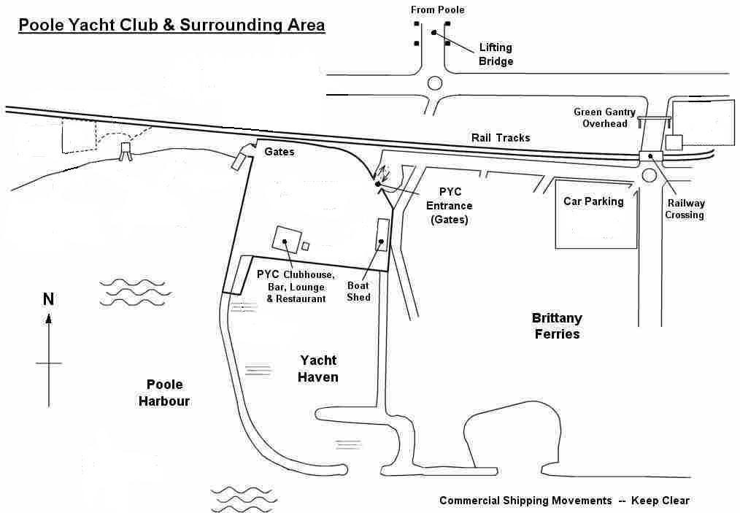

Suggested Activities for Non-Sailors
Boat trips round the harbour from Poole quay, stopping off on Brownse Island with its home of Scouting and red squirrels.
Boat trips to Wareham (town on main river feeding Poole Harbour) from Poole quay
Bournemouth beaches, 15minutes by car
Visit Studland with its beaches and sand dunes via the Sandbank ferry.
Visit Dorset’s Jurassic coast
Walk the nature reserve of Arne with its flower and fauna
Poole Yacht Club Entry Form Safety Number ……..
Contender Osprey Open 30th June and 1st July 2018 office use only

Please complete in ink

Class. ……………….. Boat Name - …………………- Sail Number ………………
Competitor Details | Helm | Crew
Name
Date of Birth
Home Address
Post Code
Club
Contact Phone/Mobile

Competitor Declaration: I agree to be bound by the rules as defined in the Racing Rules of Sailing, and all other rules that govern this event. I accept the Statement of Liability in the Notice of Race which excludes the right to claim compensation in certain circumstances. During the event we will hold valid and current third party insurance for the boat of at least £3 000 000

Competitor Signatures

Please complete the Medical Declaration over the page.

Parent/Guardian Details: (Required for all helms and crews who are under 18 years of age at date of entry)
Parent/Guardian details | Helm | Crew
Name of Parent/Guardian
Home Address
Post Code
Contact Phone/Mobile
Person acting in Loco Parentis
( if applicable)
Contact Phone/Mobile

Parent/Guardian Declarations: (Required for all helms and crews who are under 18 years of age at date of entry)
Under law, this competitor is my dependant. I accept the Statement of Liability in the Notice of Race, which excludes the right to claim compensation in certain circumstances. During the event the boat sailed by my dependant will have a valid and current third party insurance of at least £3million. I confirm that my dependant is competent to take part. I will be responsible for my dependant throughout the event, and during the time he/she is afloat I will be available at the event venue, or I will inform the Race Office in writing who is acting in loco parentis. I confirm that the above named participant(s) may be photographed and/ or filmed during the event and images may be used in publicity material for Poole Yacht Club.

Parent/Guardian Signatures

Fees- Entry fee Osprey £32. Contenders £27
Please enclose a cheque made out to The Poole Yacht Club

Contender Open 30th June and 1st July 2018

Medical Details CONFIDENTIAL WHEN COMPLETED

Medical Details | Helm | Crew
Competitors Name:
What are the things that a Coach/Shore Crew/Helper/Rescuer/Fellow Sailor has to watch out for which might be health or life threatening to you, either on shore or on the water eg: asthma/diabetes

What should they do if any of these things happen?
Medication and or allergies that doctors should be aware of in case of emergency:
Emergency Contact if not Parent/Guardian:
Contact Phone/Mobile:

Medical Declaration:

I confirm that this information is correct and complete to the best of my knowledge and may be shared on a “need to know” basis. I authorise the Race Officials and other persons nominated by the Race Committee to administer first aid if required in an emergency.

Over 18 Competitor or
Parent/Guardian Signatures
Date Signed:

CONFIDENTIAL WHEN COMPLETED

