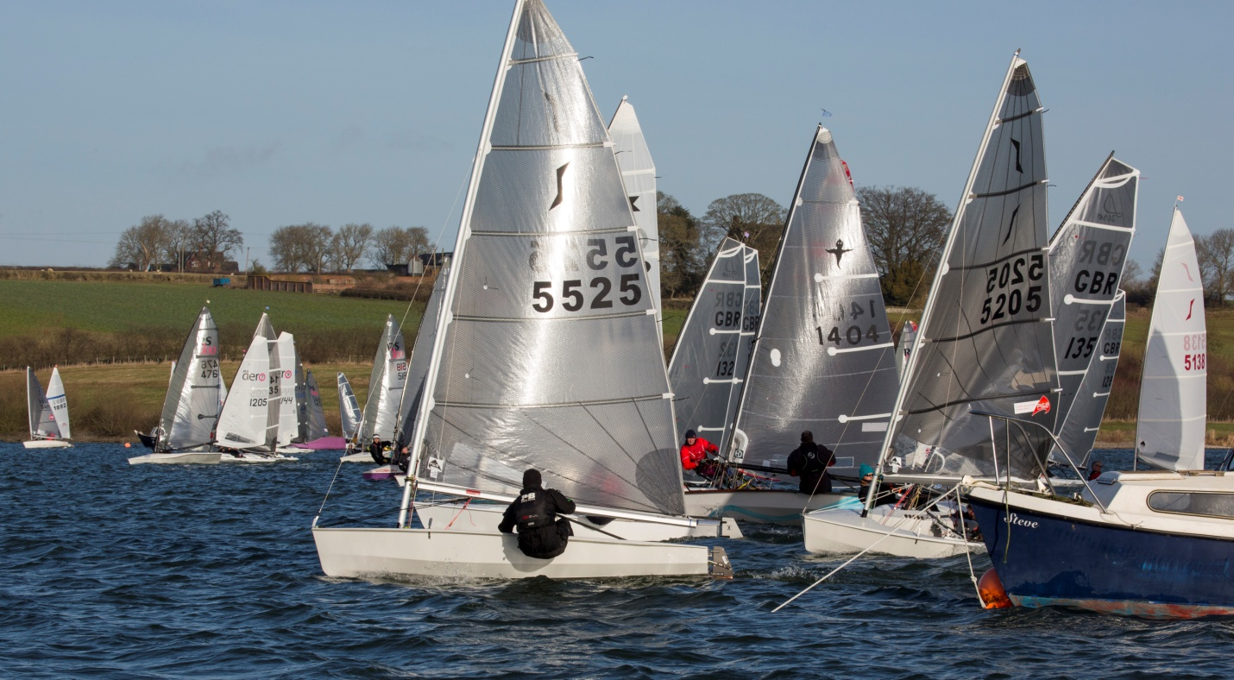

Briefing 10.30 am**. Four races, three to count** Race 1 11.00 am.

Race 1 and 2 back to back

**Lunch**

Race 3 and 4 back to back

Entry Fee - £15 ( **Free cake and sandwiches at Prize Giving, Bar Open )**

(Including Richard Butterfield Trophy)

Further details and entry form at [www.northamptonsailingclub.org](http://www.northamptonsailingclub.org)

Fleet Captain – Neil Pitcher solofleet@northamptonsailingclub.org

**Solo Open Meeting**

**Midland Series sponsored by Dinghy Rope**

**www.dinghy-rope.co.uk**

**Saturday 10th June 2017**

Hom of the Steve Nicholson Memorial Trophy